11th ACVVC LIFE MEMBERSHIP PIN DESIGN BALLOT
YOUR LIFE MEMBERSHIP #____________________
(If you don’t know it print your name below)

YOUR NAME________________________________

YOUR CHOICE:_______________________________
(Print the number of the design you like best)

PLEASE MAIL THIS BALLOT TO THE ADDRESS BELOW
POSTMARKED NOT LATER THAN DEC 31, 2012.

PETE WALTER
11th ACVVC LIFE PIN
8 TALLOWOOD DRIVE
WESTAMPTON, NJ 08060-3721

OR E-MAIL YOUR NAME, LIFE MEMBERSHIP # AND CHOICE TO:

BASEPIECE70@VERIZON.NET

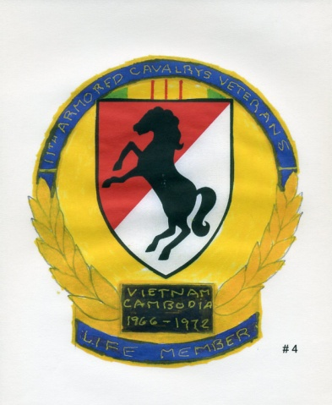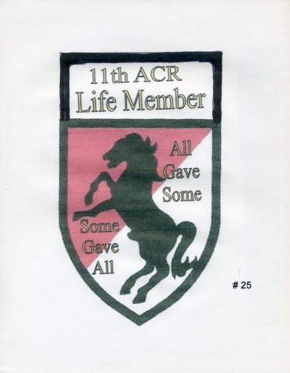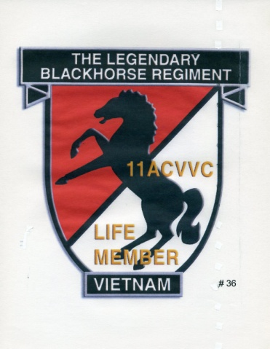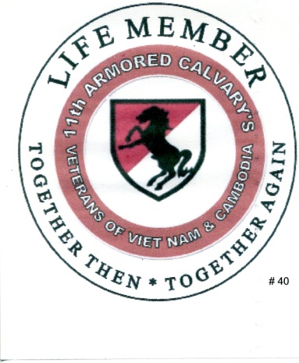
# 3 # 4 # 25 # 36 #40

