History of the
11th Armored Cavalry Regiment
ESTABLISHMENT OF THE 11th CAVALRY
2 February 1901
After attaining victory in the Spanish-American War of 1898, the United States found itself with the new task of Territorial Administration. In large part, the job fell to the regular Army. Found to be undermanned for the mission, Congress increased the standing army by five infantry and five cavalry Regiments. Thus, on 2 February 1901, the 11th Cavalry Regiment was the first of five newly formed cavalry regiments. The 12th, 13th, 14th and the 15th Cavalry Regiments followed.
On 11 March 1901, the first recruits of the new Regiment reported for training at Fort Myer, Virginia. A combat tested veteran of the Civil War, who also gave distinguished service in the Spanish-American War, was tasked with raising the Regiment and serving as its first commanding officer. The 11th Cavalry was exceptionally fortunate in having the standard set by such an experienced and resourceful officer as Colonel Francis Moore; FIRST COLONEL OF THE REGIMENT.
"I have 400 men who have never seen a horse, I have 400 horses who have never seen a man, and I have 15 Officers who have never seen a man or a horse." This sentiment was fully shared throughout the newly formed 11th, 12th, 13th, 14th and 15th Cavalry regiments.
THE FIRST UNIFORM
The headgear is referred to as a “campaign hat.” It resembled a fedora with a crease down the middle of the crown. The shirt was made of dark blue chambray and the trousers were a buff-colored khaki with canvas leggings over low cut boots. A dark blue coat was used for dress occasions while a khaki coat was issued for field use. When mounted, the trooper wore brass rowel spurs and gauntlets (riding gloves). His holstered .38 caliber double action Colt revolver hung opposite a Model 1860 Light Cavalry Saber on a canvas “Mills” belt that held double rows of cartridges for his rifle. Slung from his saddle was a tin cup, a flat circular canteen, a blue blanket, and the famous smokeless powder Krag-Jorgensen magazine fed carbine.
The typical soldier began his day with “Stable Call” at 0500 hrs. Tasked with caring for his mount before addressing his own needs, the Trooper rubbed down, fed and exercised his horse. Next came routine with which soldiers of today can readily identify. This involved close order drill, athletics, guard duty, and honing the skills of scouting and patrolling. Afternoons were devoted to mounted drill, one of which was known as the “Monkey Drill.” This maneuver required the Trooper to ride bareback hands free while putting his horse through various maneuvers. The pay of the 11th Cavalry soldier in the early 1900′s was $13.00 a month for a six-day workweek. Sunday was a day off when Troopers received mounted passes that permitted riding through the countryside.
PHILIPPINE ISLANDS
(Philippine Campaign Medal)
By June 1901, the Regiment was fully activated, although its three Squadrons were separated to posts in Missouri, Vermont and Virginia. Six months of intensive training culminated with orders to depart for the Philippines to assist in putting down the insurrection there. First Squadron traveled overland and embarked out of San Francisco to Hawaii, Wake Island and then on to the Philippines. Second and Third Squadrons left by way of New York on the U.S.A.T. Buford (Army Transport Service), arriving in Manila after a sixty-one day voyage which included passage through the Suez Canal.
Future President William Howard Taft was the First Civil Governor of the Philippines and his governorship of the islands was a high mark in colonial administration for any nation. He had First Squadron dispatched to Samar, Second Squadron to Batangas Province, and Third Squadron to northern Luzon. Experiencing jungle warfare for the first time, the Regiment fought dismounted. The name of Private Clarence L. Gibbs, KIA 4 March 1902, was the first to be placed on the 11th Cavalry Roll of Honor.
By May 1902, working from satellite camps attached to larger base camps, daily patrols of Troopers had swept the countryside of guerrillas and the Regiment began the transition to garrison operations. The tropical climate, illness and guerrilla warfare had depleted the Regiment to one-third strength.
Orders home were issued in March 1904 and within a month, the Regiment was scattered around the United States once more. HQ and Second Squadron were at Ft. Des Moines, Iowa; First Squadron was assigned to the historic cavalry post at Ft. Riley, Kansas; Third Squadron was split between Ft. Sheridan, Illinois and Jefferson Barracks, Missouri. It was not until summer 1905 that the Regiment served together for the first time when it was consolidated at Ft. Des Moines.
CUBAN PACIFICATION
(Army of Cuban Pacification Medal 1906-09)
The Cuban republic was established after the 1898 Spanish-American War. In 1901 the Platt Amendment, a rider attached to the Army Appropriations Bill of 1901, stipulated the conditions for U.S. intervention in Cuba that virtually made the island an U.S. protectorate. Under the terms of this bill the United States established - and retains to this day - a naval base at Guantanamo Bay.
In mid-1906 Cuban internal strife caused the United States to invoke the Platt Amendment and send troops to the island nation in an attempt to restore order. William Howard Taft, now Secretary-of-War, sent his Philippine Insurrection veterans, the experienced 11th Cavalry Regiment under the command of Colonel Earl D. Thomas, 2nd COLONEL OF THE REGIMENT.
Pulled from its annual maneuvers at Fort Riley, Kansas, First Squadron returned to Fort Des Moines while the balance of the regiment left for Cuba by way of Newport News. The regiment arrived in Havana ahead of its horses on 16 October 1906 and set up base camp outside the city. A storm with hurricane force winds struck the next day, destroying the camp and battering the ships still at sea so badly that over 200 mounts were killed. The troopers of the day quickly recovered and assumed control of western Cuba. Regimental Headquarters was established in Pinar del Rio after a 29 hour/110 mile force march by Troop F. The mission of the 11th Cavalry was to ‘show the flag’ by conducting mounted patrols throughout the countryside between the villages. While in Cuba the regiment was joined by its new commander, Colonel James Parker, 3rd COLONEL OF THE REGIMENT. “Galloping Jim” (the longest serving Colonel) continued peacekeeping operations during the Regiment’s two-year stay, demonstrating to the natives that the US Army’s Cavalry was ready for any and all eventualities. Although conflict is at times inevitable, the 11th Cavalry Regiment best serves the country when it commands respect and thereby averts war through a show of strength. This will be repeated time and again throughout the history of the regiment.
By 1909, the political situation in Cuba was stable and the regiment was recalled. In late February, they began hurried preparations to embark out of Havana and return to the United States. The reason for the hasty departure became apparent when, upon arriving once again in Newport News, Virginia on 1 March 1909, they were immediately ordered to Washington D.C. by train. Arriving in a severe blizzard, the troopers of the 11th Cavalry Regiment nonetheless readied themselves for the task at hand. The next day, 4 March 1909, the Regiment assumed a place of honor in the inaugural parade of their old friend and now President, William Howard Taft.
After the inauguration of President Taft, the regiment settled into garrison life at its new home at Fort Oglethorpe, Georgia. The reprieve was short lived however, as in early 1911 the regiment was deployed to the Texas/Mexico border in response to Mexico’s internal political turmoil, which threatened to spill into the United States. This would prove to be the first of many border postings for the 11th Cavalry. The crisis soon eased and the regiment returned to Fort Oglethorpe in November.
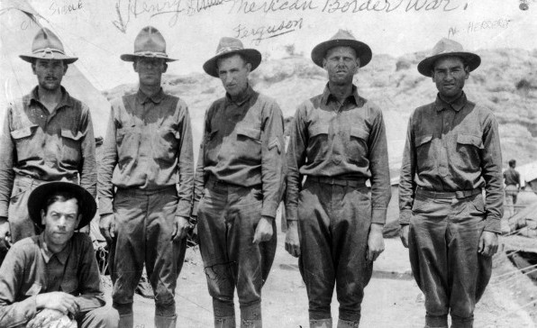
11th Cavalry: Mexican Border patrol 1913. DLIFLC & POM Archives
LUDLOW MASSACRE
In May 1914, the 11th Cavalry found itself on the go again, this time to Colorado. A violent-marred coal strike had culminated in the so-called Ludlow Massacre in which several miners along with two women and eleven children were killed in the small town of Trinidad. Secretary of War Lindley M. Garrison dispatched the Regiment to perform the difficult and delicate task of restoring order to a community torn by rioting in the wake of the massacre. It was even more frustrating for our troopers considering many came from the coal mining villages of West Virginia and they knew what life is like working under these conditions. The troopers of the 11th Cavalry performed their sensitive mission well, winning praise for their "poise, justness, absolute impartiality, and effectiveness." The Regiment returned to Georgia in January 1915 for a stay of a little over a year.
FOOD FOR MARCHING ORDER
The menu of the troops must not be forgotten. In every game of chance, there is always a possible element of disappointment, but there is neither chance nor disappointment in the matter of meals for troops. They were dealt the inevitable “government straight” consisting of canned baked beans, canned tomatoes, canned corn bread (“Corned Willie”), coffee and prunes. This may not sound so bad, but it did get monotonous.
THE GREAT WAR
World War I began on 28 July 1914, one month after the assassination of the heir to the Austro-Hungarian throne by a Serbian terrorist in Sarajevo, Bosnia. The United States was not immediately drawn into “The Great War”, as it was then known. American lives were lost however, during the sinking of the British liners Lusitanian and Arabic in May and August of 1915. After hostile reactions from American citizens and vehement protests from the U.S. Government, Germany announced the cessation of unlimited submarine war. Meanwhile, events much closer to home were commanding the attention of the 11th Cavalry.
PUNITIVE EXPEDITION
MEXICO – 1916
(Mexican Service Medal)
On 9 March 1916, the Mexican revolutionary “Pancho” Villa raided the town of Columbus, New Mexico. President Woodrow Wilson ordered Brigadier-General John J. “Black Jack” Pershing to lead a Punitive Expedition into Mexico to destroy Villa’s rebel army. On 12 March the 11th Cavalry under the command of James Locket (4th COLONEL OF THE REGIMENT) was ordered to report to Pershing. The lead elements of the Regiment moved out that very night.
A feature of railroad troop trains is their ability for “rapid” transit. At every station stop, a delegation of the Red Cross met the trains with hot coffee and sweet smiles. At El Paso, Texas the 11th Cavalry was ordered to go directly to Columbus, New Mexico to join the expedition going into Mexico. Lieutenant-Colonel Henry T. Allen led First Squadron as the forward element into that country.
The Provisional Squadron of the 11th Cavalry was formed under the command of Major Robert L. Howze. On 10 April 1916, a Villista patrol engaged Major Howze's advance guard. In the ensuing battle, the Regiment suffered its first casualties of the campaign with three wounded and Private Kirby of Troop M was killed. Trooper Kirby was buried where he fell. The Regiment had forced marched for 21 days over 571 miles. Two troops (companies) of the 10th Cavalry, the “Buffalo Soldiers" reinforced the Regiment at Parral. Cut off from their base at Colonia Dublan, the Squadron was sorely in need of re-supply. “Our animals were low in flesh. Officers had to watch their men to keep them from eating part of the corn allowance of the horses.”
THE LAST CHARGE
On 5 May 1916, the 11th Cavalry had the honor of making what proved to be the last mounted charge in regular US Cavalry history. This would be the first of a number of ‘lasts’ the 11th would undertake in its career as a regular Army unit, including the last forced march and the last mounted combat patrol. The account of the ‘Last Charge’ was noted as follows: “The column advanced onto the village to be found out by guards. The bugler sounded and with guidon flying on high the charge began. The troopers entered Ojo Azules with pistols firing, bugle sounding out orders, commands being screamed, and the thunder of hoofs all putting fear into the hearts of the enemy.” To the average trooper it was just, another day of service to his country.
Howze’s War Diary – 5 May 1916
5 May 1916 report to General Pershing: “We made an over-night march to Ojo Azules, distance thirty-six miles. Reached here at 5:45 a.m. unfortunately one-half hour after daylight. We surprised Julia Acosta, Cruz Domingues and Antonio Angel; jumped them. Had a running fight for two hours. Drove their bands into the hills between here and Carichic. Killed forty-two verified by officers; captured several and some fifty to seventy-one ponies and mules. It is believed that we killed Angel, although identification not completed. We rescued a Carranza lieutenant and four soldiers just before they were to be shot. We followed the enemy, consisting of about 140, until our horses were wholly exhausted, but the chase did not stop until the enemy's left flank had been broken up entirely. In fact, those who escaped us did so as individuals. Our discovery was by Villista herd guards, which fired at our Indians, and alarmed the enemy, which ran pell mell, firing at us in their flight. The remarkable part is although the clothing of several of our men was hit; not a single man was wounded, thanks to the utter surprise and confusion of the enemy. We lost three or four horses. It is needless to say that officers and men behaved as would be expected.”
The 11th Cavalry withdrew from Mexico on 5 February 1917; five days after Germany resumed a policy of unrestricted submarine warfare against American shipping on 31 January.
THE ZIMMERMAN TELEGRAM
International Intrigue affects the 11th Cavalry
1 March 1917 saw the publication of a German memorandum proposing a defensive alliance with Mexico in case of war between Germany and the United States with the proviso “…that Mexico is to recover the lost territory in New Mexico, Texas and Arizona…” which caused a wave of American outrage. Alfred Zimmerman, German Foreign Secretary, had sent the coded message on 19 January, which also contained the suggestion that Mexico urge Japan to join the Central Powers, to von Eckhardt, the German Minister to Mexico. British Naval Intelligence intercepted and decoded it, giving a copy to the U.S. Ambassador to Britain on 24 February. After verification, it was released to the press 1 March. At the time, the British Navy had the German merchant fleet bottled up in the Gulf of California port of Santa Rosalia.
The United States' declaration of war on Germany, enacted by Congress on 6 April 1917, found the Regiment pausing at Ft. Bliss, Texas as part of a provisional First Cavalry Division. Due to the threat outlined in the Zimmerman telegram and the proximity of the German merchant fleet, a detachment of the 11th was stationed on the border at Camp John Beacom in Calexico, California (nearest border crossing to the German fleet) while another was stationed in the Campo area. These detachments continued border duty until 1920. Within a month new orders came and Colonel James B. Irwin (6th COLONEL OF THE REGIMENT) led the remainder of the Regiment back to Chickamauga Park, Georgia, near Ft. Oglethorpe. The next two years saw various elements of the 11th Cavalry scattered throughout the South and West.
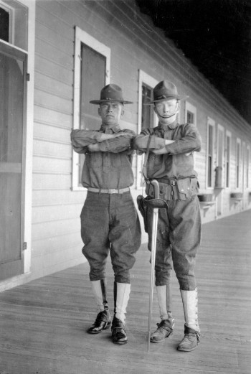
11th Cavalry troopers on the porch of their barrack posing with what appears to be a M1913 enlisted cavalry saber, also known as the Patton sword or saber, Presidio of Monterey, circa 1920's. DLIFLC & POM Archives
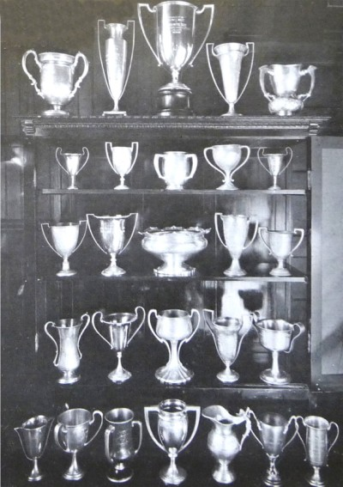
Some of the cups won by the Eleventh Cavalry, circa 1922
THE QUIET YEARS
On 9 July 1919, the main body of the Regiment departed Ft. Meyer, Virginia on a transcontinental trek to a new duty station at the Presidio of Monterey, California. Second and Third Squadrons, whose troops had been scattered throughout Georgia, Wyoming, and California, soon rejoined the HQ. Here the Regiment remained for over two decades, during the “Quiet Years.”
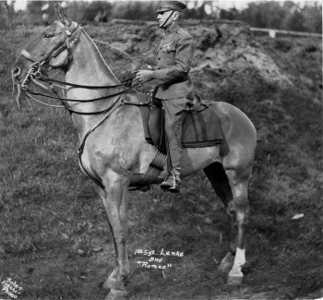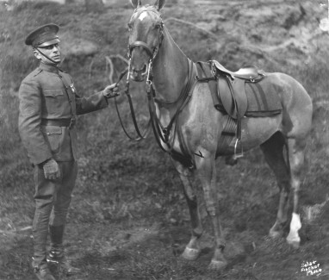
11th Cavalry: Sgt. Lenke on “Romeo”, Presidio of Monterey, circa 1920's. DLIFLC & POM Archives
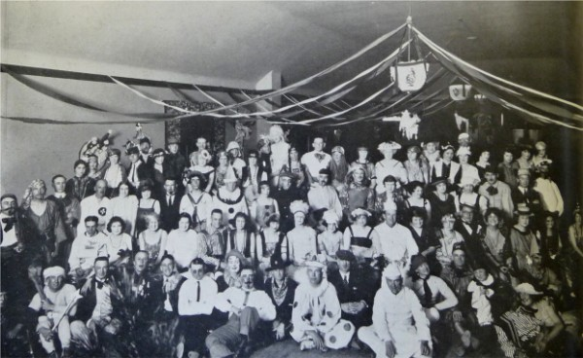
Costume dance 11th Cavalry, Presidio of Monterey, circa 1922.

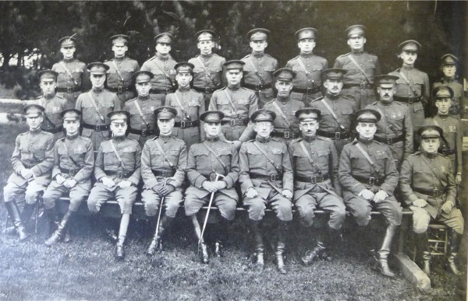
Officers of the 11th Cavalry at the Presidio, circa 1922

Presidio duties included exercising horses on the beaches of Monterey, extended war maneuvers in the forests and deserts of California and summer training of ROTC personnel at Fort Lewis, Washington. In the 1930′s, running the Citizen’s Military Training Corps (CMTC) Program in Monterey was an additional requirement. In the comparatively genteel Army of the 1920′s and 1930′s, the Regiment’s spare time was filled with unit competitions in polo and horsemanship.
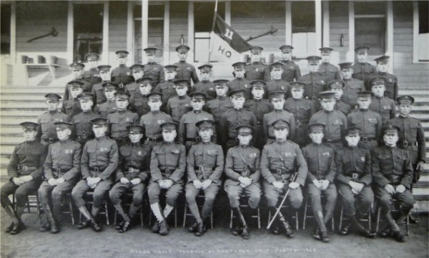
Headquarters Troop, 11th Cavalry, Presidio of Monterey, circa 1922.
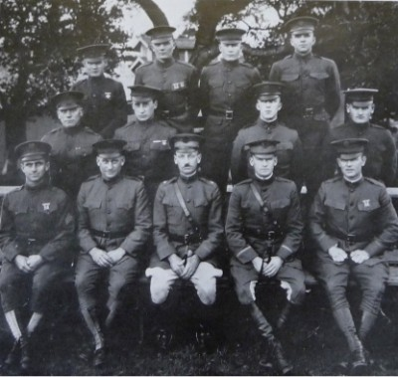
First Squadron Headquarters Detachment, 11th Cavalry, Presidio of Monterey, circa 1922.
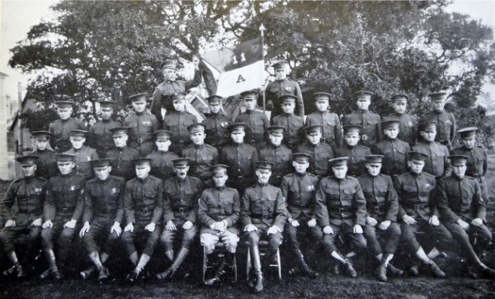
"A" Troop, 11th Cavalry, Presidio of Monterey, circa 1922.
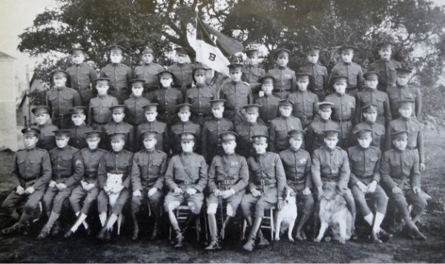
"B" Troop, 11th Cavalry, Presidio of Monterey, circa 1922.
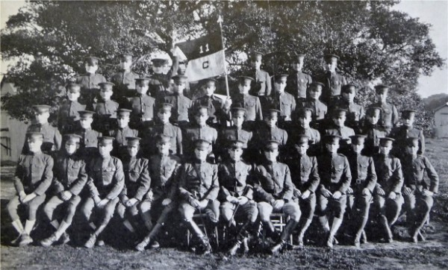
"C" Troop, 11th Cavalry, Presidio of Monterey, circa 1922.
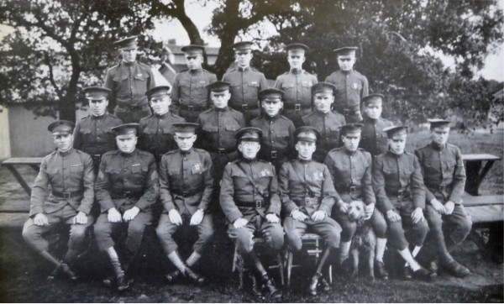
Second Squadron Headquarters Detachment, 11th Cavalry, Presidio of Monterey, circa 1922.
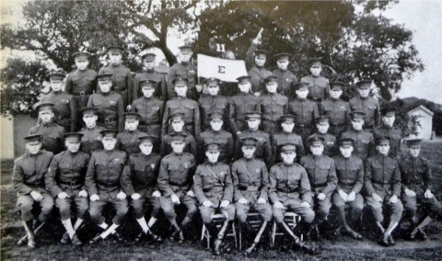
"E" Troop, 11th Cavalry, Presidio of Monterey, circa 1922.
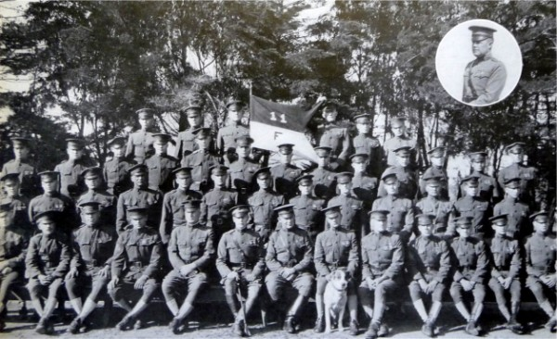
"F" Troop, 11th Cavalry, Presidio of Monterey, circa 1922.
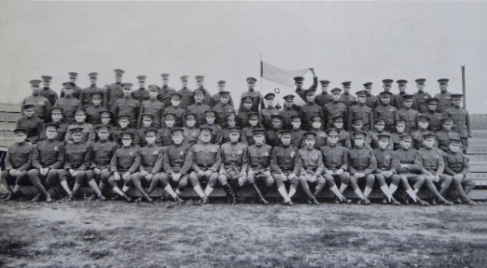
"G" Troop, 11th Cavalry, Presidio of Monterey, circa 1922.
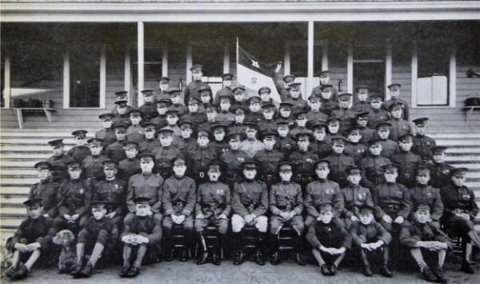
Supply Troop, 11th Cavalry, Presidio of Monterey, circa 1922.
THE GREAT PRESIDIO OIL FIRE
OF 1924
At 1000 hours on September 14, 1924, the 11th Cavalry once again found itself in a fight. However, this time there were no bullets involved. The Presidio of Monterey was located right next to the Tidewater-Associated Marine Terminal, an oil storage facility. One of the oil storage tanks had been struck by lightning and set on fire. The fires in the wooden oil storage tanks were soon found to be almost impossible to control and the fire spread. Those warehouses closest to the fire contained grain and hay for the horses of the Regiment. The Army began to evacuate these warehouses and the work was completed just 10 minutes before the first oil tank exploded, covering the buildings with burning oil. As the burning tanks collapsed, rivers of burning oil flowed down the streets towards Monterey Bay. The heat from the fires became so intense that people several hundred feet away were burned.
Troopers fought the fires from behind sections of wooden fencing used as shields against the heat. Ladders were placed up against the sides of the burning tanks and troopers were ordered up them to spray water directly into the tanks. Many of these troopers died when the tanks collapsed and they were thrown into the burning oil.
Five days later, when the fire had finally burning itself out, it was found that 26 men were missing from the rolls and several hundred were injured. (Through the Army Memorial Program, many streets of Monterey, California, bear the names of the men who died fighting the fire. The bravery of these troopers is still remembered today, for if the oil had been allowed to flow down onto the town of Monterey and the many wooden structures, a greater number of loss of life and property would have most certainly been greater if it was not for the 11th Cavalry.
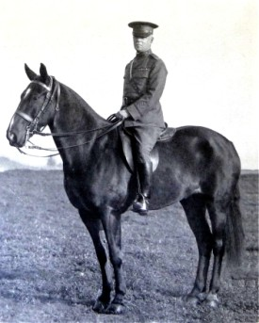
Colonel John Murray Jenkins, Commanding, 11th Cavalry, Presidio of Monterey, circa 1922
LESSONS LEARNED: With this and other similar above ground oil storage tanks fires, lessons were learned, that have affected the oil storage procedures industry wide.
That is, due to the fixed roofing and with repeated drainage/refilling; would naturally generate spacing between the oil and roofing unit. Vapors would develop and it is this, that most believed actually ignited, when the lighting struck. Lightning rods are of little value in these situations. When rainwater or the fire extinguishing water would land on top of the oil, this in time would descend as oil being lighting then water. With the tempter of the burning oil began reaching 212 degrees, the water converts to vapor expanding rapidly thus causing eruption of hot boiling burning oil.
This was not a familiar concept to the troopers who were working in good faith they treated the fire as a "wood burning fire" and continued to spray water onto the tanks hoping to cool the metal/wood casing enough to contain the oil. As the heat would transfer from one tank unit across to an adjacent unit that too would reach a tempter causing that unit to likewise explode, which lead to more loss of life.
Any water accumulated from previous rains that became covered with repeated "drainage/refilling of oil" generated a layering of oil-water-oil etc., when heated, expands and explodes or in this case, oil boiled up and over the sides of the containers. There are several accounts of the storage tank casings becoming too hot and collapsing inward tossing the troopers into the vat of burning oil.
Major lesson learned is that now the "tops" of these oil storage units are a floating top that does not allow the collection of vapors, distance between tanks has extended, a massive earth works have been constructed to contain the total oil within the storage unit in a designated area thus preventing expansion of the burning oil over to other units.
NOTE: Presidio Fire Station
While Brigadier General John J. "Black Jack" Pershing (along with the 11th Cav)
was withdrawing from Mexico and the conclusion of the Punitive Expedition a
tragic fire that took the lives of Pershing's wife and three of his four children. The Presidio Fire Department was the first military fire department to be established in the United States and was staffed by a civilian fire crew. The Fire Station was one of the first Army stations equipped with automotive fire engines.
THE FIRST SHOLDER SLEEVE INSIGNATIA
(The First Patch)
The 11th Cavalry was assigned to 3d Cavalry Division August 1927 - March 1933. Where they were then assigned to 2d Cavalry Division October 1933 - October 1940. The 2d Cavalry Division "Patch" was the Regiments first patch worn.
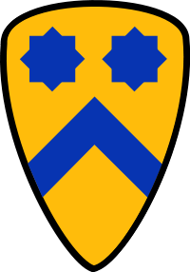
THE 11TH CAVALRY
“GOES HOLLYWOOD”
During the inter-war period, Hollywood secured the 11th Cavalry to make war movies. The Regiment was involved in the making of two motion pictures, “Troopers Three” (1929) and “Sergeant Murphy” (1937). The latter starred a promising young actor in his second film by the name of Ronald Reagan, himself an Army Reserve Cavalryman in Troop B, 322nd Cavalry. On May 25, 1937, he was appointed a second lieutenant in the Officers’ Reserve Corps of the Cavalry. Ronald Reagan was the last US President who served as a horse mounted cavalryman and the only one to “serve” with the 11th Cavalry Regiment.
THE GOLDEN GATE BRIDGE
The Regiment participated in many ceremonies, such as marking the opening of the Golden Gate Bridge at San Francisco on 1 June 1937. The guidon was entrusted into his care as the ‘D’ Troop guidon bearer commencing in 1935 until he left the Regiment in 1940. The guidon for ‘D’ Troop was carried by Pvt. Hubert Brown on that day and has been donated by him to the Regiment's museum.
“HORSE TO HORSEPOWER”
The 1920′s and 1930′s saw the gradual introduction of armored cars, trucks and motorcycles to the Regiment, supplementing the traditional horse, wagon and pack mules. Scout cars were accepted in 1935 with the later M3A1 becoming the pre-war mainstay. Special built tractor-trailers were capable of rapidly transporting eight fully equipped Troopers with their horses to any staging point. (It was also in the late 1930′s that the Regiment was issued the Garand M1 to replace the venerable Springfield M1903 rifle.)
In the mid-1930′s the US Army purchased European military equipment for testing purposes. One such item was this horse drawn munitions wagon recently recovered near Camp Locket, where the Regiment was stationed. It has been restored to the original German Army forest green color just as it was used by the 11th Cavalry. The Regiment added the distinctive crossed sabers of the Cavalry.
Field maneuvers, large-scale exercises and an occasional search and rescue mission in the mountains of Southern California gave the 11th Cavalry a unique training opportunity among the Army's Cavalry Regiments. They were able to evaluate, under as-near-to battlefield conditions as possible, the efficiency of the horse in the modern army. One such rescue mission incorporated nearly every vehicle in the regimental inventory. Using motorcycle squads, Bantam scout cars (Jeeps), the M3A1 scout car, 1½-ton trucks and the age-old horse now deployed by tractor-trailer, the Troopers combed rugged mountains for two lost infantrymen. The lessons learned in the coordination of movement and the maneuverability of the various components in the successful mission were forwarded for study to Washington D.C. The information was taken to heart. Virtually every single country entering WWII had horse mounted supply, artillery and cavalry units in combat.
Over a dozen of those countries still fielded them at war's end. In April 1945, the 4th German Cavalry Division alone surrendered 16,000 horse mounted soldiers.
WAR CLOUDS
In 1939, General George C. Marshall became Army Chief of Staff. With war clouds looming over Europe, Marshall knew it was only a matter of time before the United States was drawn into another conflict overseas. In order to prepare the 60,000-man army, he began a program to get the men out of the barracks and into the field for a year of “toughening up.” Tent camps were to be constructed and in turn various regiments of cavalry and infantry would take to the field. By September 1940, General Marshall had convinced Congress to begin the first-ever peacetime draft beginning in September 1940. In November 1940 the field rotation for the 11th Cavalry began.
The new camps for the Regiment were constructed in San Diego and Imperial counties, near the Southern California/Mexican border. Camp Seeley, near El Centro, California and Camp Morena; near Campo were built simultaneously. Camp Seeley was used for desert training, training the horses to swim with rider up (mounted) and was the location of Regiment’s rifle and machine gun ranges. Camp Morena was for mountain and cold weather training. The Regiment would rotate Squadrons between the two throughout the year. It was later decided to establish a single camp suitable to house the entire Regiment at one site. Construction of Camp Lockett (named for James Lockett, 4th COLONEL OF THE REGIMENT) in Campo, where “E” Troop had been posted in 1918, began in 1941. Built by the Quartermaster Corps, it is generally acknowledged that Camp Lockett was the last designated mounted cavalry camp constructed in the U.S. Army’s history. It remained a cavalry post for the 10th and 28th Regiments after the 11th gave up its horses. Today the El Centro/Camp Seeley area remains the home of the 11th Cavalry Horse Honor Guard (Historical) – “The Colonel’s Own.”
Led by Harold M. Rayner, (16th COLONEL OF THE REGIMENT) the main body moved from the Presidio of Monterey to the Camp Seeley/Camp Morena duty stations. By this time, the Regiment had reverted to three troops (companies) per squadron. The Regiment’s HQ, First Squadron and Provisional Squadron were based at Camp Seeley, while Second Squadron was posted at Camp Moreno. In March 1941, some 700 draftees from Illinois, Wisconsin and Michigan joined the Regiment. They were the first conscripts to ride with the Regiment.
The Regiment underwent extensive training until 7 December 1941, when the Japanese attacked Pearl Harbor. On 10 December, the entire Regiment was ordered to occupy the unfinished Camp Lockett. Those units based at Camp Morena made the five-mile trek in short order. The Squadrons based at Camp Seeley commenced what became the last “Forced March” in U.S. Horse Cavalry history, completing the ninety-mile march over extremely rocky, mountainous terrain in one and a half days. Once at Camp Lockett, horse-drawn artillery units occupied Camp Seeley while its rifle range continued to be used by cavalry units from Camp Lockett. Camp Morena was closed.
Immediately following the bombing of Pearl Harbor, there were wild reports of Japanese attacks on the California coast. Once at Camp Lockett, the regiment was posted along the United States/Mexico border for the fourth time in its history; this time to counter the rumored threat of enemy troops landing in Baja California and marching north. Once the threat was proven to be false, the 11th Cavalry Regiment was relieved by the 10th and the 28th (horse) Cavalry and stood down to await further orders. They were supposed to ship out for Australia, but many of the troopers came down with jaundice from the yellow fever vaccinations, so they remained in California for the time being.
WORLD WAR II
The summer of 1942 found the regiment reassigned to Fort Benning, Georgia where they were inactivated as a horse mounted unit and reactivated as the 11th Armored Regiment. Even then, massive reorganization efforts within the Army shuffled various elements of the regiment around – eliminated some – but eventually three distinct groups emerged from the chaos:
-Headquarters & Headquarters Troop became 11th Cavalry Group Mechanized/XIII
Corps Activated 5 May 1943 at Camp Anza, California.
-First & Second Squadron became 11th Tank Battalion/10th Armored Division
-Third Squadron became 712th Tank Battalion/90th Infantry Division
“BATTLE OF THE BULGE”
The Ardennes Offensive
The Battle of the Bulge was the largest battle ever fought by the United States and was the largest land battle of World War II. Fought from 16 December 1944 to 28 January 1945, it involved more than a million men including some 600,000 Germans, 500,000 Americans, and 55,000 British. The Germans had two Armies with ten corps (equal to 29 divisions), while the Americans fielded three armies with six corps (equal to 31 divisions). The end of the battle saw US casualties as 81,000 with 19,000 killed, 1400 British casualties with 200 killed, and 100,000 Germans killed, wounded or captured.
This epic battle has the distinction of being the only one that involved all three elements of the old 11th Cavalry Regiment. The 11th Tank Battalion was defending inside the bulge while the 712th Tank Battalion was in the relief column punching its way in. The 11th Cavalry Group anchored a sector on the northern shoulder of the bulge.
712TH TANK BATTALION
The 712th landed in France on D-Day + 23, and went into combat on 3 July 1944 on Hill 122, known as “the most expensive piece of real estate in World War II,” in terms of casualties. In the 11-day battle that lasted from 3 July to 13 July, the 90th Infantry Division suffered 7,000 casualties. The 712th fought its way through France crossing the Moselle River and then the Saar River. They came back across the Saar and plunged into the Battle of the Bulge, after which they crossed the Saar again, then the Rhine River. They had broken through the Siegfried Line and were penetrating into the heart of Germany to Amberg by the time the war ended. The 712th Tank Battalion returned to the States after the war and was inactivated at Camp Kilmer, New Jersey on 27 October 1945. The unit followed a separate lineage until it was inactivated as the 95th Tank Battalion of the 7th Armored Division on 15 November 1953. The unit rejoined the 11th Armored Cavalry Regiment in October 1958.
11TH TANK BATTALION
The 11th Tank Battalion entered combat on 2 October 1944 and fought continuously until the end of the war. One of the most dramatic contests occurred in the little village of Berdorf, Luxembourg during the German Ardennes Offensive or ‘Battle of the Bulge.’ The 11th Tank fought off relentless attacks by two entire Panzer Battalions over the course of three days. The defenders suffered only 4 dead and 20 wounded while losing only one tank and four half-tracks. They inflicted casualties of 350 known enemy dead while destroying seven tanks and three half-tracks. The gallant stand helped buy time for relief forces to move up and block any further German advance. An enemy breakthrough at Berdorf would have given the Germans a clear road to Luxembourg. One of the ‘Forward Observers’ positions was in the Berdorf Hof (Hotel), providing a clear view down the main road into the village. After the war, the 11th Tank Battalion was inactivated at Camp Patrick Henry, Virginia on 13 October 1945.
11TH CAVALRY GROUP (MECHANIZED)
The 11th Cavalry Group would be destined to carry on the Regiment name. Then Lt. Leonard D. Holder (37th COLONEL OF THE REGIMENT) of Troop B, 44th Squadron, was the first to land on the shores of France. This Troop was given the honor of being attached to General Dwight D. Eisenhower's headquarters to provide checkpoint security and escort duty for the remainder of the war. On 23 November 1944 the balance of the Group loaded onto a small fleet of Landing Ship Transports (LST’s) and crossed the channel. The first assignment was to begin aggressive patrols across the Roer River to check enemy movements. During the Battle of the Bulge the 11th Cavalry Group held the entire sector normally occupied by a division.
ROER TO THE RHINE
When the Allied offensive resumed after the Battle of the Bulge, the 11th Cavalry Group was tasked with covering the flank of XIII Corps during the push from the Roer to the Rhine. Faced with maintaining a 32-mile long screen, the Group developed the tactic of leap-frogging squadrons through the villages along the way. Constantly in contact with the enemy, the 11th Cavalry hit the Rhine River on 5 March 1945, having inflicted 487 casualties while taking only 56 themselves. Now, with the German Army prepared to contest every single inch of territory, the Blackhorse began probing the enemy defenses with across river patrols. Crossing into the German heartland on 1 April, the 11th Cavalry resumed a flanking screen for XIII Corps. Pushing ahead, virtually cut off from other friendly units and supplies, the 11th scored bold victories as they liberated more than one thousand American POW's along with several thousand slave labors from a prison camps. The 11th Cavalry pushed on to the Elbe River, reaching it on 14 April. Orders prevented them from any further eastward movement. Rather, the unit was directed to swing north in a mopping up operation.
This thrust deep into the enemy’s homeland culminated with the 11th Cavalry Group killing and wounding 632 German soldiers and capturing 6,128 prisoners. In 21 days the Regiment had moved 378 miles, suffered only 14 killed, and 102 wounded.
THE BLACKHORSE MEETS
THE RUSSIAN BEAR
4 May 1945
The 11th Cavalry Group had advanced at such a fast pace that they meet the III Russian Corps coming into Germany near Kunrau. Since Germany was to be divided into sectors, the 11th found themselves deep inside the Russian Occupation Zone. After a brief celebration between the two over the Allied victory, the 11th Cavalry Group withdrew to Hannover and began the task of army of occupation.
“THE CIRCLE “C” COWBOYS”
May 1946 – November 1948
Early May 1946 found the 11th Cavalry Group (Mechanized) reverting from horsepower back to horseflesh. The Group was re-designated the 11th Constabulary Regiment and reissued horses drawn from world-renowned Polish breeding stock. Likewise, the 11th Tank Battalion stateside was re-activated as the Headquarters and Headquarters Troop, 1st Constabulary Regiment. The horses were utilized, along with other various modes of transportation, to accomplish the mission of reconnaissance and surveillance of movements of the populace. The concern was the possible resuming of hostilities by fraction groups. This elite force roamed through its various sectors presenting a bearing of security, order and stability to the country. The distinctive “C” inside a circle on the helmets and shoulder patches earned the mounted Constabulary Regiments the nickname “Circle C Cowboys” and brought the distinction of being the last horse mounted combat patrols in US history.
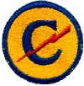
20 September 1947 saw the 1st Constabulary Regiment inactivated with the 11th scheduled to follow 30 November 1948. Both were converted and re-designated on 30 November 1948 as the 11th Armored Cavalry Regiment and inactivated.
THE BORDER LEGION
The Cold War Heats Up
(March 1957-1964)
The 11th Armored Cavalry Regiment was reactivated 1 April 1951 and assigned to Camp Carson, Colorado. Col. Brainard S. Cook, (23rd COLONEL OF THE REGIMENT) was tasked to rebuild the Regiment from the ground up. In early 1954 the Regiment moved again, this time to Fort Knox, Kentucky where they trained reservists. The Army of the 1950′s was a conscript force whose turnover rate affected every part of the Army. To counter this effect the Army created GYROSCOPE, a program that rotated entire units overseas instead of individuals. In mid-March 1957 the 11th Armored Cavalry Regiment “Gyroscope’s” to Germany, was replacing the 6th Armored Cavalry Regiment on the West German-Czechoslovakian Border. The Regimental HQ and First Battalion were sent to Straubing on the Danube River; Second Battalion moved to Landshut, 35 miles northwest of Munich; and Third Battalion settled in the historic city of Regensburg. The Regiment was now part of the Seventh Army and took up the peacetime mission of border surveillance. This is when 2Lt. Frederick M. Franks, Jr. (50th COLONEL OF THE REGIMENT) joined the 11th Cavalry for the first of several tours.
In May 1960 the Regiment added a separate Aviation Company, the precursor of larger aviation components to follow. In an effort to regain a sense of historical esprit de corps within the armored cavalry regiments, the Army reestablished the nomenclature from battalions and companies to the traditional terms of squadron and troops.
In late 1962, the Regiment was placed on full alert due to the Cuban Missile Crisis, and remained in the field close to the Czechoslovakian border until the crisis was averted - the only time in American history that the military was placed on DEFCON 2. One other interesting fact was that Third Squadron was housed in the only "fort" in Europe - Fort Skelly was their home until returning stateside in 1964, when the Regiment departed Germany for Fort Meade, Maryland.
1964 – 1966 At Ft. Meade, the men of the regiment were required to wear the 1st Army patch because armored cavalry regiments were considered “army troops.” The only identifying insignia worn by personnel was a patch depicting the familiar “allons” crest on the left breast pocket.
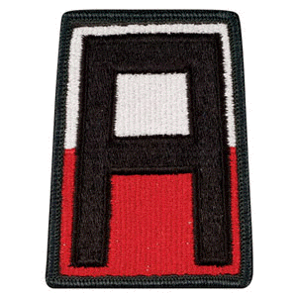

THE BLACKHORSE, BECOMES A LEGEND
VIETNAM
7 September 1966
In early 1966, the Regiment began redesigning its equipment for a new type of warfare based on recommendations from American advisors based in Vietnam. Additional armor and two more 30-cal. machine guns were added to the Regiment’s M113s, transforming them into what became known as Armored Cavalry Assault Vehicles or ACAVs. The new design of armored gun shields provided a measure of protection for the crew and track commander. The result was a rapid all terrain fighting vehicle which could deliver devastating firepower. At Vung Tau, South Vietnam, on September 7, 1966, (the Air Troop arrived in December), the Regiment made an amphibious landing under the command of William W. Cobb, (34th COLONEL OF THE REGIMENT) along with 3,762 troopers. The Regiment troops arrived in South Vietnam and quickly engaged the enemy with M-48 tanks, ACAV’s, artillery and helicopters. The 11th ACR initially enter the Republic of Vietnam under regimental status and not authorized a shoulder sleeve insignia. The Regiment established the justification to receive its own patch on 1 May 1967 from the Department of Heraldry and was the first of five Armored Cavalry Regiments to receive a distinctive shoulder sleeve insignia. Due to mission requirements and operations as an independent unit, the Chief of Staff, General Harold K. Johnson, in February 1967, authorized the warring of a distinctive patch.
As authorized by the Secretary of the United States Army, gives grants and assigns unto the 11th Armored Cavalry Regiment the Shoulder Sleeve Insignia following.
INSIGNIA
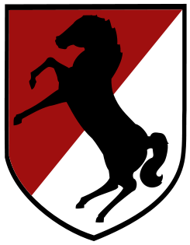
Description: On a shield 2 ¾ inch (6.99cm) in width overall divided diagonally from upper right to lower left, the upper portion red and the lower portion white, a rearing black horse facing to the left all within a 1/8 inch (.32cm) black border.
Symbolism: The colors red and white are the traditional cavalry colors and the rearing black horse alludes to the "Black Horse" nickname of the 11th Armored Cavalry Regiment.
Under the provisions of title 18 United States Code Section 101-104 the Shoulder Sleeve Insignia here given having been registered and recorded in the Institute of Heraldry United States Army are reaffirmed from this date and hereafter may borne, shown and advanced by the 11th Armored Cavalry Regiment as safe property of said insignia.
Base camp was established on November 1966 and the Regiment began reconnaissance in force operations directed at suspected Viet Cong concentrations in the provinces around Saigon.
Skeptics questioned whether armor (tanks) vehicles could play an effective role in the jungles of Vietnam. The Regiment responded to those skeptics by developing innovative tactics, techniques, and procedures that established a reputation of a relentless fighter. The main operational areas for the Regiment squadrons were the provinces around Saigon and up to the Cambodian border. When the Tet Offensive of January 1968 began, the Regiment was ordered from Long Khanh Province, moving south towards Bien Hoa and Long Binh to the defense of the city and fought street by street to overcome the attacking Viet Cong and restore security. The Regiment moved 80 miles at night through a contested area, arriving 14 hours after its initial alert notice. This superb demonstration of cavalry agility has become the trademark of this Regiment throughout its history. Always ready to try new ideas, the Regiment added a new element to its Air Cavalry Troop, the Aero-Rifle-Platoon (ARP). This airmobile unit was often sent to search and destroy suspected enemy in areas accessible only by air. History now points out that the Viet Cong were virtually annihilated during these battles. From that time forward North Vietnamese Army units, well supplied and equipped by the communist superpowers, would fight a war of attrition against the United States. Rarely however, would they risk a head-to-head confrontation with their most feared adversary, the 11th ACR.
Nine different Colonels would lead the Regiment during its extensive stay in country. One of the saddest days in the history of the Regiment occurred when Col. Leonard D. Holder, (37th COLONEL OF THE REGIMENT) was killed just after being in country only a few weeks. His aircraft malfunctioned after receiving small arms fire and crashed. He died a few days later from injuries. He is the only Colonel of the Regiment to have died while in command of the Regiment.
In July of 1968, the 39th Colonel of the Regiment, George S. Patton Jr., assumed command and soon applied his expertise in armored combat tactics. The Regiment moved the armor off the roads and into the jungles in search of the enemy, a concept previously thought not feasible. This action was so successful that the enemy could no longer move freely and was forced to seek sanctuary inside neutral Cambodia. Colonel Patton coined the phrase, “FIND THE BASTARDS, THEN PILE ON”, which remains today as the Regiment’s battle cry.
August 1969 saw another innovation under the command of James A. Leach (40th COLONEL OF THE REGIMENT) when an entire Armored Cavalry Assault Vehicle (ACAV) Troop using modified M113 personnel carriers was airlifted by C130 aircraft. This enabled the unit to be in combat at night, move by aircraft in the morning and be able to re-engage the enemy at a different location by that evening. These bold maneuvers kept the enemy at bay whenever he ventured out of his Cambodian sanctuaries.
On 7 December 1969 Donn A. Starry (41st COLONEL OF THE REGIMENT) assumed command. By 28 April 1970 the Regiment was alerted to a major offensive that would finally “take-out” the North Vietnamese sanctuaries in Cambodia. From well-established bases inside Cambodia, the communists would strike out into South Vietnam and then return across the border to resupply and regroup. The 11th ACR received just 72 hours to refit, re-supply, and move into a staging area south of the Cambodian Fishhook. This required Third Squadron, which was the farthest away at the time, to road march 145 kilometers to its assembly area.
On 1 May 1970 the Blackhorse stood ready to spearhead the Allied incursion into Cambodia. Massive air strikes by B-52′s had already prepared the target area. Second Squadron led the attack, followed by Third Squadron while First Squadron provided rear guard security. Trailing the Regiment were elements of the First Cavalry Division and several Army of the Republic of Vietnam (ARVN) units. At 1030 on 1 May 1970 the Blackhorse crossed into Cambodia in an area called the Fish Hook to deny the enemy of these safe havens. The Regiment was ordered to force-march 40 kilometers further north to capture the City of Snoul. Within the given 48 hours they reached the city and attacked with incredible ferocity on 5 May, reminiscent of those mounted cavalrymen charging into Ojo Azules, Mexico after Pancho Villa in 1916. Then Major Frederick M. Franks (50th COLONEL OF THE REGIMENT), Second Squadron's S3, joined in an assault on an enemy anti-aircraft position, when a NVA grenade landed near him. Colonel Starry burst into motion and actually dove into Franks trying to knock him out of the way of the blast. Major Frank’s life was spared with his chicken plate (flack vest), but his left foot was a total mess. Colonel Starry hadn’t worn his chicken plate that day – if he had, he would have only been scratched. Starry remains the only Colonel of the Regiment to date to have been wounded while in Command. With Snoul secured and 148 enemy killed, the Blackhorse began a systematic search of the surrounding area. Colonel Starry turned over the reigns of the Blackhorse to John L. Gerrity, (42nd COLONEL OF THE REGIMENT) on 22 June 1970. The Regiment had captured or destroyed massive amounts of supplies and equipment depriving the enemy of desperately needed succor.
The Cambodian Incursion was the last unrestrained offensive use of U.S. ground forces in the war. The capture and destruction of tons of enemy weapons and supplies left the enemy devastated and demoralized. The result was a smoother transition of responsibility to the South Vietnamese military as the American combat forces continued to withdraw. Countless American and allied lives were saved by the operation that left the North Vietnamese Army crippled and unable to mount an effective offensive for some time.
In February of 1971, First and Third Squadron redeployed to the U.S. and were inactivated. On 6 April 1972, after almost six years of continuous combat the Blackhorse Regiment’s Air Troop and Second Squadron departed Vietnam having never lost a battle. As the Regiment troopers left Vietnam Wallace H. Nutting, (43rd COLONEL OF THE REGIMENT) told them “We have all been privileged to ride together with the Blackhorse in the cause of freedom. There is much on which we can look with pride. Stand tall in the saddle. Allons!” One year later, on 29 March 1973, the last American combat troops were withdrawn from Vietnam. Within two years, on 30 April 1975, Saigon fell to the North Vietnamese.
In all, 730 Blackhorse troopers made the ultimate sacrifice by helping to protect and defend the people of South Vietnam from their north communist aggressors. The Regiment’s wounded totaled 5,761. Three 11th ACR troopers were awarded the Medal of Honor, two of which were posthumous. The Regiment went home from the toughest, most agonizing conflict that has ever engaged American soldiers on foreign soil. Whatever the notation of the war’s outcome that enters into the history books, it will be said that: “The Regiment troopers have performed with estimable devotion to duty and unsurpassed gallantry. It was the Regiment’s finest hour.” In its best performance, the gallant troopers of the Blackhorse Regiment earned fourteen battle streamers for bravery and forever secured a place in American military history and legend.
In testimony whereof these letters are given under my hand of the City of Alexandria in the Commonwealth of Virginia this first day of May in the year of Our Lord one thousand nine hundred and sixty seven and in the Independence of the United States of American one hundred and ninety one.
Colonel, Adjutant General's Corps
Commanding
Staff, General Harold K. Johnson, in February 1967,
authorized the warring of a distinctive patch.
1st. Medal of Honor Recipient
YANO, RODNEY J. T.
Rank and organization: Sergeant First Class, U.S. Army, Air Cavalry Troop, 11th Armored Cavalry Regiment. Place and date: Near Bien Hao, Republic of Vietnam, 1 January 1969. Entered service at: Honolulu, Hawaii. Born: 13 December 1943, Kealakekua Kona, Hawaii. Citation: Sfc. Yano distinguished himself while serving with the Air Cavalry Troop. Sfc. Yano was performing the duties of crew chief aboard the troop’s command-and-control helicopter during action against enemy forces entrenched in dense jungle. From an exposed position in the face of intense small arms and antiaircraft fire he delivered suppressive fire upon the enemy forces and marked their positions with smoke and white phosphorous grenades, thus enabling his troop commander to direct accurate and effective artillery fire against the hostile emplacements. A grenade, exploding prematurely, covered him with burning phosphorous, and left him severely wounded. Flaming fragments within the helicopter caused supplies and ammunition to detonate. Dense white smoke filled the aircraft, obscuring the pilot’s vision and causing him to lose control. Although having the use of only 1 arm and being partially blinded by the initial explosion, Sfc. Yano completely disregarded his welfare and began hurling blazing ammunition from the helicopter. In so doing he inflicted additional wounds upon himself, yet he persisted until the danger was past. Sfc. Yano’s indomitable courage and profound concern for his comrades averted loss of life and additional injury to the rest of the crew. By his conspicuous gallantry at the cost of his life, in the highest traditions of the military service, Sfc. Yano has reflected great credit on himself, his unit, and the U.S. Army.
2nd. Medal of Honor Recipient
WICKAM, JERRY WAYNE
Rank and organization: Corporal, U.S. Army, Troop F, 2d Squadron, 11th Armored Cavalry Regiment. Place and date: Near Loc Ninh, Republic of Vietnam, 6 January 1968. Entered service at: Chicago, Ill. Born: 19 January 1942, Rockford, Ill. Citation: For conspicuous gallantry and intrepidity in action at the risk of his life above and beyond the call of duty. Cpl. Wickam, distinguished himself while serving with Troop F. Troop F was conducting a reconnaissance in force mission southwest of Loc Ninh when the lead element of the friendly force was subjected to a heavy barrage of rocket, automatic weapons, and small arms fire from a well concealed enemy bunker complex. Disregarding the intense fire, Cpl. Wickam leaped from his armored vehicle and assaulted one of the enemy bunkers and threw a grenade into it, killing 2 enemy soldiers. He moved into the bunker, and with the aid of another soldier, began to remove the body of one Viet Cong when he detected the sound of an enemy grenade being charged. Cpl. Wickam warned his comrade and physically pushed him away from the grenade thus protecting him from the force of the blast. When a second Viet Cong bunker was discovered, he ran through a hail of enemy fire to deliver deadly fire into the bunker, killing one enemy soldier. He also captured 1 Viet Cong who later provided valuable information on enemy activity in the Loc Ninh area. After the patrol withdrew and an air strike was conducted, Cpl. Wickam led his men back to evaluate the success of the strike. They were immediately attacked again by enemy fire. Without hesitation, he charged the bunker from which the fire was being directed, enabling the remainder of his men to seek cover. He threw a grenade inside of the enemy’s position killing 2 Viet Cong and destroying the bunker. Moments later he was mortally wounded by enemy fire. Cpl. Wickam’s extraordinary heroism at the cost of his life were in keeping with the highest traditions of the military service and reflects great credit upon himself and the U.S. Army.
3rd. Medal of Honor Recipient
FRITZ, HAROLD A.
Rank and organization: Captain, U.S. Army, Troop A, 1st Squadron, 11th Armored Cavalry Regiment. Place and date: Binh Long Province, Republic of Vietnam, 11 January 1969. Entered service at: Milwaukee, Wis. Born: 21 February 1944, Chicago, 111. Citation: For conspicuous gallantry and intrepidity in action at the risk of his life above and beyond the call of duty. Capt. (then 1st Lt.) Fritz, Armor, U.S. Army, distinguished himself while serving as a platoon leader with Troop A, near Quan Loi. Capt. Fritz was leading his 7-vehicle armored column along Highway 13 to meet and escort a truck convoy when the column suddenly came under intense crossfire from a reinforced enemy company deployed in ambush positions. In the initial attack, Capt. Fritz’ vehicle was hit and he was seriously wounded. Realizing that his platoon was completely surrounded, vastly outnumbered, and in danger of being overrun, Capt. Fritz leaped to the top of his burning vehicle and directed the positioning of his remaining vehicles and men. With complete disregard for his wounds and safety, he ran from vehicle to vehicle in complete view of the enemy gunners in order to reposition his men, to improve the defenses, to assist the wounded, to distribute ammunition, to direct fire, and to provide encouragement to his men. When a strong enemy force assaulted the position and attempted to overrun the platoon, Capt. Fritz manned a machine gun and through his exemplary action inspired his men to deliver intense and deadly fire, which broke the assault and routed the attackers. Moments later a second enemy force advanced to within 2 meters of the position and threatened to overwhelm the defenders. Capt. Fritz, armed only with a pistol and bayonet, led a small group of his men in a fierce and daring charge, which routed the attackers and inflicted heavy casualties. When a relief force arrived, Capt. Fritz saw that it was not deploying effectively against the enemy positions, and he moved through the heavy enemy fire to direct its deployment against the hostile positions. This deployment forced the enemy to abandon the ambush site and withdraw. Despite his wounds, Capt. Fritz returned to his position, assisted his men, and refused medical attention until all of his wounded comrades had been treated and evacuated. The extraordinary courage and selflessness displayed by Capt. Fritz, at the repeated risk of his own life above and beyond the call of duty, were in keeping with the highest traditions of the U.S. Army and reflect the greatest credit upon himself, his unit, and the Armed Forces.
“THE FRONTIER OF FREEDOM”
THE FULDA GAP
1972 – 1994
On 17 May 1972 the 14th Armored Cavalry Regiment furled its colors and was reflagged as the 11th Armored Cavalry Regiment. The Regiment once again unfurled its colors in Germany. This time it was at the famous Fulda Gap. The Regiment assumed a new, two-fold mission; defending the Fulda Gap against a possible Warsaw Pact attack while also conducting day-to-day surveillance of 385 kilometers of the Iron Curtain dividing East and West Germany. The Regiment relieved the inactivated 14th Armored Cavalry Regiment and joined V Corps – “The Victory Corps.”
The Regimental mission in the General Defense Plan (GDP) was to strongly reinforce the United States Army Europe (USAEUR) as the covering force for V Corps. The importance of the Fulda Gap is that it offers to any attacker from the east the shortest and most direct route across the middle of West Germany. A successful thrust through the Fulda Gap, aimed at seizing the Rhine River crossings at Mainz and Koblenz, would sever West German and NATO forces defending it.
As so often in the Regiment’s history, it had to disperse its squadrons. Located at Downs Barracks in the City of Fulda were the Regimental Headquarters and First Squadron, known as “Ironhorse.” Second Squadron, known as “Eaglehorse,” was stationed at Daley Barracks in the spa City of Bad Kissingen. Third Squadron, known as “Workhorse,” established its new home at McPheeters Barracks, Bad Hersfeld. Fourth Squadron, or “Thunderhorse,” was in Fulda, at Sickels Army Airfield, where aviation elements were stationed. Fourth Squadron grew to become one of the largest aviation units in the Army with 74 helicopters. A comprehensive effort to upgrade/modernize the Regiment’s various installations was begun by Crosbie Saint, (47th COLONEL OF THE REGIMENT). The “Quality of Life” program made living conditions more suitable for the Regiment.
Modernization brought with it organizational change on a comparable scale. The Regiment grew in size, became more diverse in its capabilities and increased its self-sufficiency. The Regiment now numbered over 4,600 soldiers, a four-fold increase over the original 1901 troop count. The first female soldier assigned to the Regiment, was SP-4 Cynthia Engh to HHT Regiment, RS-1 (1974-76). In 1985 the newly formed Combat Support Squadron, known as “Packhorse,” was activated in Fulda. Maintenance Troop was the largest in the Regiment with 366 troopers. Of special note was the 58th Combat Engineer Company, known as the “Red Devils,” who won the Itschner Award, symbolic of the best Combat Engineer unit in the U.S. Army. In 1991 the 511th Military Intelligence Company, known as “Trojanhorse,” was selected as the best company-sized intelligence unit in the Army.
Border operations were serious business. Each cavalry troop of the Regiment could expect border duty four times a year – each tour lasting 21-30 days. Duty day began with a 0600 border briefing, a review of SOP’s and an update on the latest sightings or incidents. Part of the mission was to demonstrate to potential adversaries that the Blackhorse, representing all NATO forces, was well-disciplined and ready to fight. The trooper's gear had to be clean, boots highly polished, uniforms pressed, weapons spotless, and radios fully operational. After inspection, the troopers were divided into reaction forces; observation posts (OP's), and patrol duty (PD’s). Usually two armored vehicles with 10 men would respond virtually without notice to any contingency along the border. The crews had 10 minutes to be moving out of the camp gate – fully equipped, weapons mounted, ammunition on board. Patrolling was a 24 hours a day – 7 days a week function.
Observation Posts (OP’s) served as base camps as well as vantage points for observation. First Squadron occupied OP Alpha near Hunfeld-Schlitz-Lauterbach. Second Squadron was at Camp Lee northeast of Bad Kissingen near Bad Neustadt. Troops were dispatched to OP Tennessee. Third Squadron manned two OP’s; Romeo, overlooking the Eisenach-Bad Hersfeld autobahn, at Herleshausen, which was a legal crossing, point.
THE WALL CAME DOWN
9 November 1989
The Warsaw Pact and the legitimacy of the Eastern Europe’s Communist military regimes were disintegrating. The stage was clearly set for a dramatic transformation of the European status quo that had existed since the Cold War began.
One historic day changed the mission of the Regiment in Fulda irrevocably. On 1 March 1990 the Regiment ceased border operations altogether and closed its OP’s. Less than eleven months after the border opened for the two Germanys to re-unite, the Blackhorse lost its claim of being a “Border Regiment.”
The Regiment’s legacy was a justifiable pride at having played an important role in one of the greatest victories of military history, a victory all the more remarkable for having been won without firing a shot.
THE GULF CRISIS
(Southwest Asia Service Medal)
The unexpected surprise Iraqi invasion of Kuwait on 2 August 1990 triggered the Gulf Crisis that gripped the world’s attention.
The Regiment was not deployed into the Gulf as a unit. The first deployment of 200 troopers included aircrews, mechanics, truck drivers, physician’s assistants, intelligence analysts and others. The scout platoons of Troop E and Troop K deployed as units. In the brief, but violent ground campaign that routed Saddam Hussein’s Army, one group of Blackhorse scouts, the 1st Platoon of Troop E distinguished themselves. While fighting as part of the 3rd ACR, led by 1st Lt. Tom Johnson and Staff Sergeant Richard Shelton, Troop E moved over 325 Kilometers in less than 60 hours, finishing the war just south of the Iraqi City of Basra. This one platoon captured thirteen enemy prisoners and destroyed thirteen trucks, two command bunkers, and the communications bunker. None of the scouts of Troop E, nor any other Blackhorse trooper, suffered any casualties.
The end of the actual hostilities in the Gulf did not result in a return to normalcy. Far from it, the aftermath of Saddam Hussein’s defeat triggered an uprising of Iraq’s oppressed Kurdish minority. The Iraqi military bloody suppression of the Kurdish uprising sent hundreds of thousands of Kurds fleeing into the mountainous wastes of southeastern Turkey and western Iran. The world watched in horrified wonderment when the United States took the lead in responding to this intolerable situation. American and Allied military units were directed to deliver relief supplies to the refugees.
The morning of 10 April 1991, V Corps directed the Blackhorse to deploy an aviation task force to supervise the relief operations in Turkey. This was no different from the “No-Notice” deployment to join General “Black Jack” Pershing, in 1916 in Mexico. The Regiment responded quickly and deployed for Operation PROVIDE COMFORT. Within 70 hours of receiving first warning orders, Task Force Thunderhorse, under the command of Major John Mainwaring, launched from Fulda and landed in Diyarbakir, on an austere and remote airfield in southeastern Turkey. Fourth Squadron played a leading role in PROVIDE COMFORT. Fourth Squadron was the foundation from which massive allied helicopter fleets emerged: flying hundreds of sorties, delivering supplies, flying Special Forces teams and relief workers in and out of refugee camps, evacuating the sick and wounded, and inserting the Allied forces to protect the Kurds from Iraqi interference.
In orders dated 16 May 1991, as part of the Operation POSITIVE FORCE, the Joint Chiefs of Staff directed the 11th ACR to deploy immediately to Kuwait in order to sustain a presence there.
13 June 1991, only two weeks after the first Blackhorse soldier had arrived in theatre, the Regiment assumed from 1st Brigade, 3d Armored Division the responsibility for defending Kuwait. The Regiment’s new base camp was a sprawling complex surrounded by an eight-foot high wall.
The three line squadrons took turns pulling “Z Cycle”, a designation that included responsibility for security. Manning gates, towers, the Z Squadron kept a platoon-size Quick Reaction Force (QRF) on alert around the clock, seven days a week. The QRF deployed off the compound without notice at least twice daily, a muscle-flexing exercise.
On the morning of 11 July a defective vehicle heater triggered a motor pool fire in the north compound of Blackhorse Base Camp. Despite valiant efforts to extinguish it, the blaze burned out of control and began detonating ammunition stored in and around the Regiment’s vehicle fleet. The resulting shower of shrapnel and unexploded ordnance forced the evacuation of the entire compound and caused extensive damage.
Some fifty Blackhorse troopers suffered injuries that day, a number that would have been far higher had it not been for numerous individual acts of heroism and the Regiment’s disciplined response to the emergency. Miraculously, there were no fatalities.
Gen. H. Norman Schwarzkopf, Commander-in-Chief of the United States Central Command, visited the Regiment. He presented the Soldier’s Medal for Heroism to three Blackhorse soldiers:
Major Ricky Lynch
Staff Sergeant Charles Rogers
Private Eric Tomlinson
As the Regiment returned from the Gulf in September 1991 it had to confront this period of change with an odd mixture of uncertainty and unpredictability. The “good guys” and “bad guys” could not be identified, as before. In a world wracked by religious and ethnic passion, economic rivalry, and the frustrated aspirations of hundreds of millions of people, the prospects for lasting peace and harmony seemed remote. Prudent nations and wise soldiers would “keep their powder dry”.
SOUTHWEST ASIA
Kuwait
Cease-Fire
(Battle Streamer)
INACTIVATED
15 October 1993 – 15 March 1994, Germany
It is always a time of great sorrow when a Regiment with such distinction is ordered to furl its colors. As the military was down sizing, the Regiment was inactivated, but not for long.
THE BEST OF THE BEST,
ALLONS!
NOW TRAINS TODAY’S ARMY
ACTIVATED
16 October 1994 Fort Irwin, California
The Regiment now serves as the opposing force (OPFOR) in exercises designed to train Army battalion and brigade task forces in tactical and operational level skills under near-combat conditions. The Regiment formerly publishes the “Red Thrust Star”, a quarterly magazine to disseminate accurate and current information regarding the doctrine, organization, equipment, and tactics of all potential adversary military forces.
Most knowledgeable leaders and soldiers alike, consider the 11th Armored Cavalry Regiment the best-trained mechanized force in the world. Continuing in the NTC tradition of Lead, Train, Win, the Blackhorse stands ready to respond to any mission to which it may be called.
NOTE: The famous writer Tom Clancy wrote a book entitled Executive Order, in which he mentions the 11th Armored Cavalry Regiment as being the premier regiment in the U. S. Army and that they went into the Gulf region again to stop a dictator. It was based on the training and experiences acquired at Fort Irwin, California.
IRAQI FREEDOM/WAR ON TERRIORISM
DEPLOYMENT
January 2005 - 17 March 2006
On 4 July 2004, the Regiment received deployment orders for Operation Iraqi Freedom. Previously, in June the 58th Combat Engineers, Red Devils, was the first to deploy attached to 2nd BDE, 10th Mountain Division in Baghdad, Iraq. 2nd Squadron deployed in December 2004 to Babil Province, to conduct support and stability operations with the 155th Mississippi National Guard. 1st Squadron deployed in January 2005 to Baghdad, Iraq. Over the course of the year they were attached to four different Brigade Combat Teams conducting full spectrum operations in the Baghdad area of operations. The Regimental Headquarters deployed to Mosul Iraq that same month and assumed duty as the division headquarters for Multi National Force North-West.
The Regimental Support Squadron was faced with the dual mission of providing the Regimental Rear Command Post and continuing to support the rotational training mission. 1/221 Cavalry, Nevada ARNG, was activated and deployed to Fort Irwin in the fall of 2004, formed the core of NTC's premier Opposing Force. On two separate continents the Regiment demonstrated cavalry panache and flexibility, performing its wartime mission within a tradition of unmatched excellence that no other separate brigade has been called on to perform.
The Regiment returns to Fort Irwin to reorganize as a deployable heavy brigade combat team while continuing to serve in rotational support for the military at large.
DUAL MISSION
(OPFOR comes to an end)
June 2006
Mission Statement:
On order, 11ACR deploys to an area of operations and accomplishes all assigned missions to fight and win our nation's wars; executes rotational support through fielding a trained and disciplined force to train our Army.
Most knowledgeable leaders and soldiers alike, consider the 11th Armored Cavalry Regiment the best-trained mechanized force in the world. Continuing in the NTC tradition of Lead, Train, Win, the Regiment stands ready to respond to any mission to which it may be called.
NOTE: The famous writer Tom Clancy wrote a book entitled Executive Order, in which he mentions the 11th Armored Cavalry Regiment as being the premier regiment in the U. S. Army and that they went into the Gulf region again to stop a dictator. It was based on the training and experiences acquired at Fort Irwin, California.

ALLONS - Blackhorse forever!

